Happy Easter

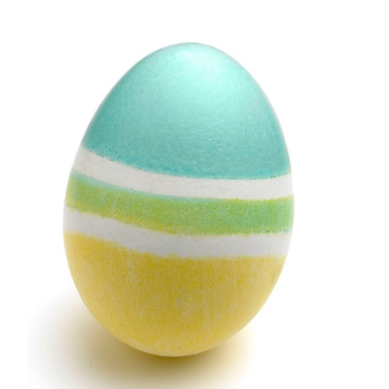

Roscrea/Birr School Completion Programme
scprb@eircom.net
A Message from us to you:
Hi all, I hope you have a lovely Easter and enjoy eating your Easter egg. Now is a good time to play our circle games with your family. I wonder will they enjoy the Grump Frog and Change Three Things as much as you do. Our college student Eilís has very kindly made these fun activity sheets for you. I hope you enjoy them.
If you want to show us your work you can email it to us on scprb@eircom.net
We are looking forward to seeing you all soon. Please stay safe. X X
Dani & Mairéad

Eilís (LIT Student) ~ I hope that you are enjoying all the chocolate, and I am looking forward to seeing you soon.

FOR YOU TO DO:
- COMPETITION – Name the Sheep in the Picture.
- The Easter Word Scramble
- Easter Find and Colour
- Easter Four in a Row Multiples. ENJOY!
- The Easter Word Search

Happy Easter
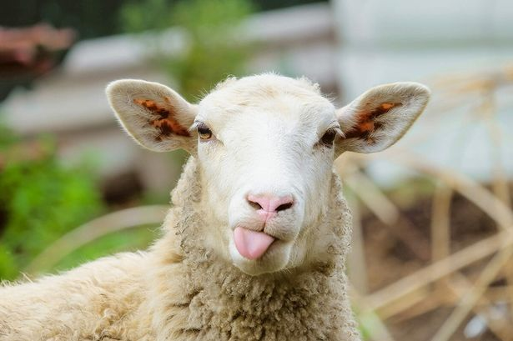

My Name is______________________________
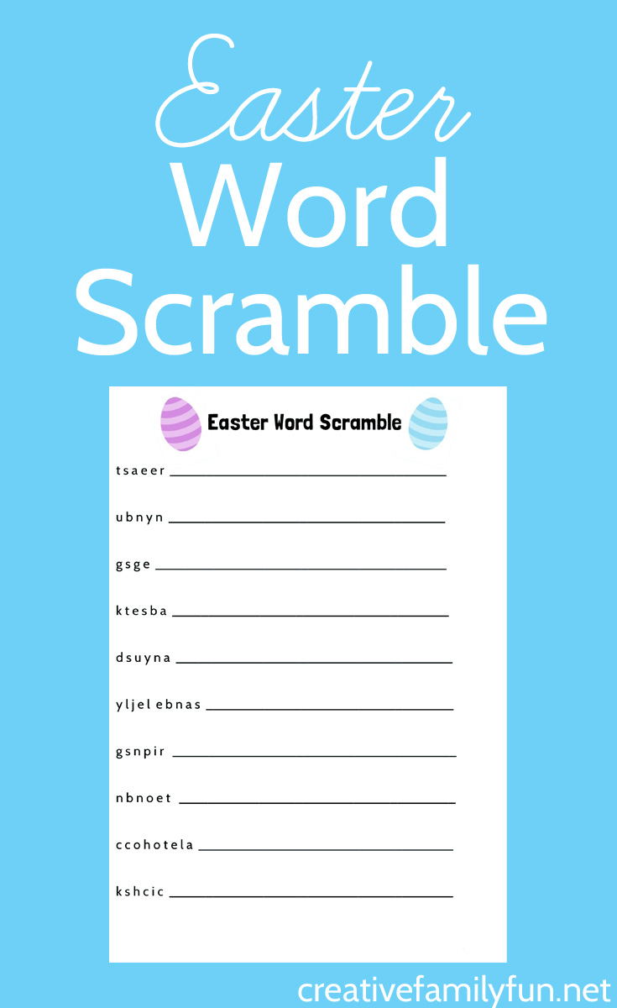
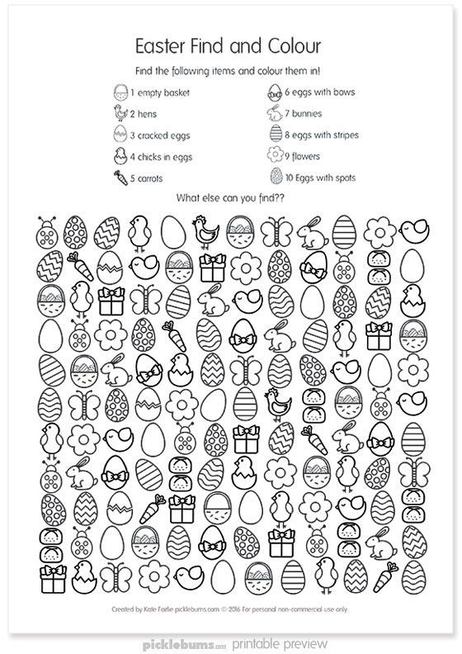
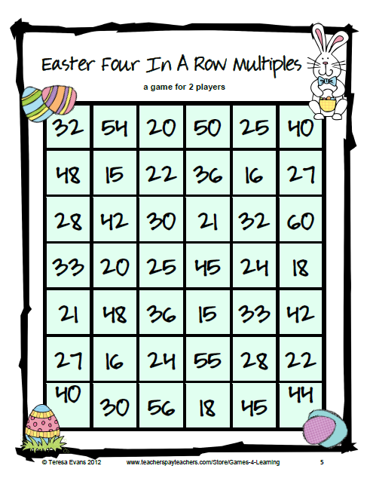

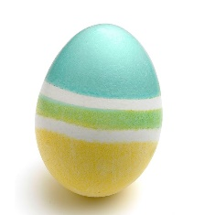
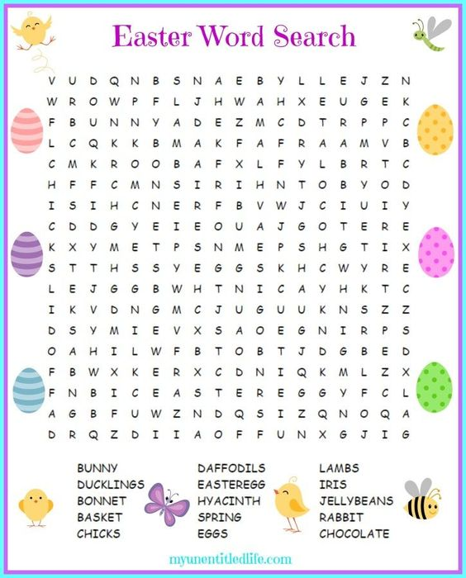
Happy Easter!!!!

