St.Brendan’s P.S.
Digital Learning Framework 2018 – 2023
2018+

Birr,Co.Offaly

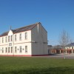

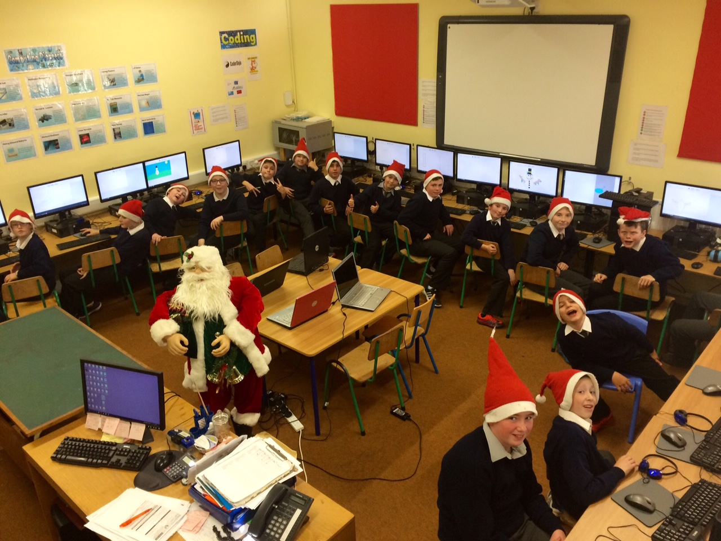

St. Brendans PS

Digital Learning Framework

Introduction:
The development of this plan was set out as a priority area by the school to comply with the Department of Education publications ‘circular 0001/2017’,Digital Learning Framework and ‘Digital Strategy for Schools’.
There are four key aspects to this plan:
- Overall approach to e-learning to include the role of school leadership, planning for e-learning and the vision of an e-learning culture in the school.
- ICT in the curriculum, to include targets for each class level and examples of best practice in the school.
- Professional development issues, to include staff training.
- The ICT infrastructure in the school, to include a maintenance and refurbishment plan, budget and technical issues.
School Details:
St. Brendan’s is an all-boys DEIS school in Birr Co. Offaly of approximately 190 students. The school has one stream of each mainstream class with 2 special classes ( MGLD / ASD) and another ASD class to open September 2019.
Overall approach towards e-learning:
Vision for e-learning here in St Brendans:
In line with the guidance provided by the National Council for Technology in Education (NCTE), the approach in St Brendans is to emphasize the integration of ICT across the curriculum, in order to improve the quality of teaching and learning. Therefore ICT is not a subject or a curriculum in its own right. It is a tool that can add value to the teaching and learning process when it is used appropriately. The purpose of computer literacy is the same as all teaching and learning, to awaken and to support the development of intellectual curiosity.
However, parents and teachers can overestimate the benefits of exposure to ICT for children. Some suggest that technology does little beyond distract children from real learning opportunities much of which could better be accomplished by pen and paper and traditional teaching. While children may have a passionate engagement with technology, some research suggests that it can lead them to trial and error responses (click and see) and guesswork answers. Technology can detract from time spent socially, from imagining.
At the same time, we are educating children who live in a technological age (digital natives) and so our teaching and learning must reflect that reality. Pedagogically, e-learning can be highly motivating for the learner and particularly for those children who find the more traditional methodologies of the school setting constraining. In that light, we will strive to maximize the potential for children’s learning using ICT, where appropriate.
Our vision for e-learning is about trying to ensure that the children begin to develop a critical appreciation of the role of ICT in society and develop habits which reflect an ethical and responsible use of ICT.
St. Brendan’s is committed to the implementation of an e-learning policy based on the following principles:
- ICT is a cross curricular tool, not a subject in its own right
- ICT is an essential part of the administration of the school
- Schools have a role to ensure that all pupils in the school, not just those with access to technology at home, can access an e-learning environment
At present, we are focusing on Domain 1 and Domain 2 from the DLF and will review this in January 2020. We hope to include domain 3 and 4 teaching and learning then and also including aspects from leading and management domains.
Domain 1 : Learner Outcomes

STANDARDS | STATEMENTS OF EFFECTIVE PRACTICE | STATEMENTS OF HIGHLY EFFECTIVE PRACTICE
Pupils enjoy their learning, are motivated to learn and expect to achieve as learners | Pupils use appropriate digital technologies to foster active engagement in attaining appropriate learning outcomes.  Pupils use digital technologies to collect evidence and record progress. | Pupils use appropriate digital technologies to foster their active, creative and critical engagement in attaining challenging learning outcomes.  Pupils use digital technologies to collect evidence, record progress, evaluate and reflect, and to create new solutions and/or products
Pupils have the necessary knowledge, skills and attitudes required to understand themselves and their relationships | Pupils have a positive attitude towards the use of digital technologies and are aware of possible risks and limitations.  Pupils understand the potential risks and threats in digital environments. | Pupils have a positive attitude towards the use of digital technologies, being aware of possible risks and limitations, and have the confidence and skills to realise the benefits.  Pupils can confidently protect their digital identity and manage their digital footprint.
Pupils demonstrate the knowledge, skills and understanding required by the primary curriculum | Pupils can use a range of digital technologies to demonstrate the knowledge, skills and understanding required by the Primary School Curriculum.  Pupils use digital technologies effectively to develop their knowledge, skills and understanding in accordance with the content objectives, learning outcomes, skills and concepts of the Primary School Curriculum | Pupils, in collaboration with their teacher and/or parents, follow their individual learning needs and preferences, with the aid of appropriate digital technologies  Pupils use digital technologies in highly effective ways to develop their knowledge, skills and understanding in accordance with the content objectives, learning outcomes, skills and concepts of the Primary School Curriculum

Domain 2: Learner Experiences

STANDARDS | STATEMENTS OF EFFECTIVE PRACTICE | STATEMENTS OF HIGHLY EFFECTIVE PRACTICE
Pupils engage purposefully in meaningful learning activities | Pupils use digital technologies for sourcing, exchanging of information to develop understanding and support basic knowledge creation. | Pupils use a variety of digital technologies for knowledge creation to source, critique, and manage information and to reflect on their learning.
Pupils grow as learners through respectful interactions and experiences that are challenging and supportive | Digital interactions, among pupils and between pupils and teachers, are respectful and positive, and conducive to well-being. | Digital interactions, among pupils and between pupils and teachers, are respectful, challenging and support the well-being of all pupils
Pupils reflect on their progress as learners and develop a sense of ownership of and responsibility for their learning | Pupils use digital technologies to collect evidence, record and reflect on their progress, and develop their competence as self-directed learners. | Pupils use digital technologies to creatively and critically develop their competence as autonomous, self-directed learners and are able to set meaningful personal goals for future learning.

ACTION TO BE TAKEN

Domain 1: Learner Outcomes

Standard- Pupils enjoy their learning, are motivated to learn and expect to achieve as learners.
Our school are and will continue to implement the following to achieve this standard:
● Using tablets for number in maths across all classes
● Tablets for problem solving in senior classes
● Digital storytelling using tablets across all classes
● Scratch for literacy and Numeracy in senior classes
● Creating ebooks in the classroom across all classes
● Project based learning using ICT in the senior classes

Standard- Pupils have the necessary knowledge, skills and attitudes required to understand themselves and their relationships
Our school will create ebooks in the classroom to achieve this standard.

Standard- Pupils demonstrate the knowledge, skills and understanding required by the primary curriculum
Our school are and will continue to implement the following:
● Project based learning with ICT
● Using Tablets in SESE
● Using Tablets for number in Maths
● Using Beebots in Infant classes
● ICT for tangrams in Maths
● Digital video for Gaeilge
● Tablets for literacy in all classes

Domain 2: Learner Experiences

Standard- Pupils engage purposefully in meaningful learning activities
Our school will implement the following actions:
● Creating ebooks in the classroom
● Cross curricular learning with Scoilnet Maps
● ICT & Numeracy- A Senior class maths lesson
● Creating a volcano ebook

Standard- Pupils grow as learners through respectful interactions and experiences that are challenging and supportive
Our school will:
● Use online tools for writing
● Fis Film Project
● Project based learning with ICT

Standard- Pupils reflect on their progress as learners and develop a sense of ownership of and responsibility for their learning
Our school will:
● Use ePortfolios across various subjects

RESOURCES (some need to be purchased)

- Tablets
- Laptops
- Desktops
- Reliable Broadband
- Book Creator
- Toontastic
- Storybird
- Adobe Spark Video
- Problem solving websites/apps
- Scoilnet
- World Book Online
- DK find Out!
- Dúchas.ie
- Kahoot for assessment
- Digital portfolio task- seesaw app
- www.oxfordowl.co.uk
- The literacy shed
- Storyline Online
- Scratch
- BeeBots
- Various websites and apps

Success Criteria: How will we know for sure that the plan is working in classrooms?

- Using the standards and statements of highly/effective practice from the domains in the DLF.
- Each teacher will be issued twice termly a page pertaining to the Digital Learning Plan, in which teachers will write in brief bullet points what ICT they used and in what subjects each month and return it to the Principal. ISM member and principal will review and plan ahead.

Class: | School Year: | Month:
Subject | ICT used (bullet points)
Maths

English

Gaeilge

SPHE

PE

Drama

Art

Music

History

Geography

Science

Ratification of 5 Year Digital Learning Plan 2018 – 2022

This policy was adopted by the Board of Management on _________________

Signed: _________________________ Signed: __________________________
Chairperson of Board of Management Principal

Date: __________________________ Date: __________________________

Date of next review: __________________

