**Mandatory Template 3:**

**Notification regarding the Board of Management’s**

**Annual review of the Child Safeguarding Statement**

To: Patron / Parents Association / School Community / DES inspectorate

The Board of Management of **St Brendan’s PS** wishes to inform you that:

• The Board of Management’s annual review of the school’s Child Safeguarding Statement was completed at the Board meeting of 10th October 2022

• This review was conducted in accordance with the “Checklist for Review of the Child Safeguarding Statement” published on the Department’s ‘website [www.education.ie](https://www.education.ie/en/Schools-Colleges/Information/Child-Protection/mandatory-template-2.docx)

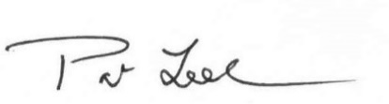

Signed _____________________________________ Date 10/10/2022

Chairperson, Board of Management

Signed  Date 10/10/2022

Principal/Secretary to the Board of Management